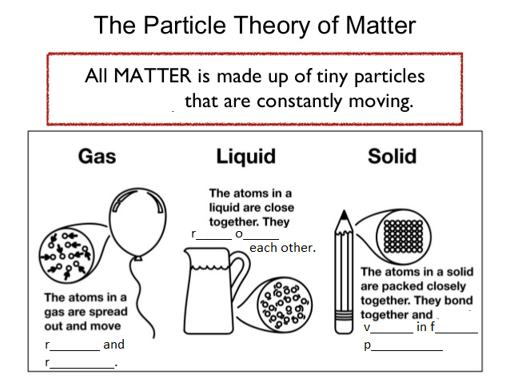
The Particle theory of Matter=

Solids
Particles _______________ in fixed position. The bonds holding particles together are very strong

Liquids
Particles _____________ over each other. The bonds holding them together are strong.

Gasses
Particles move ____________ and _____________. The forces holding the particles together are weak.

Matter
Matter is anything that has ____________ and takes up __________________.
Matter can occur in 3 states _______________, ________________ and _____________.
Matter can change from one state to another.
This is an example of a __________________ change. In a ______________ change no new substance is made, but the material changes ________________ or _____________.
There are names for the changes of state. Use the following words to fill in the table below.
Melting, freezing, boiling, condensing and sublimation.

_____________ | Gas |  |  | ___________
_____________ | __________  (Vaporisation) |  | _____________ | ___________
_____________ | Liquid |  |  | ___________
_____________ | _______________ |  | ___________ | ___________
_____________ | Solid |  |  | ___________

The particles in matter are ________________ moving.

The particles in matter are held together with forces called ___________.
In solids the _____________ are very _____________.
In liquids the ___________ are ____________.
In gasses the __________ are _____________.

Situation | Name of change of state
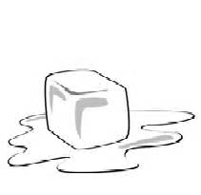

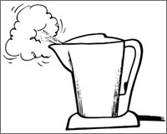
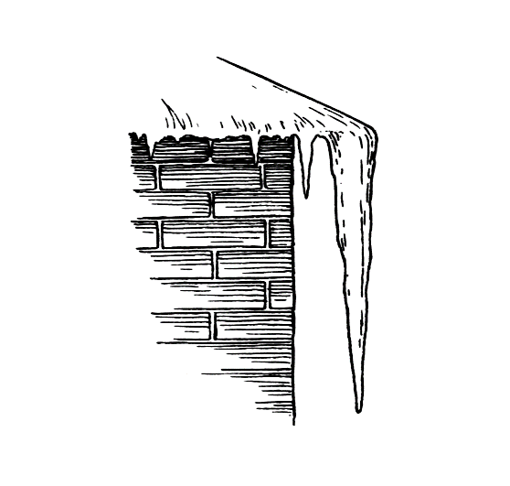
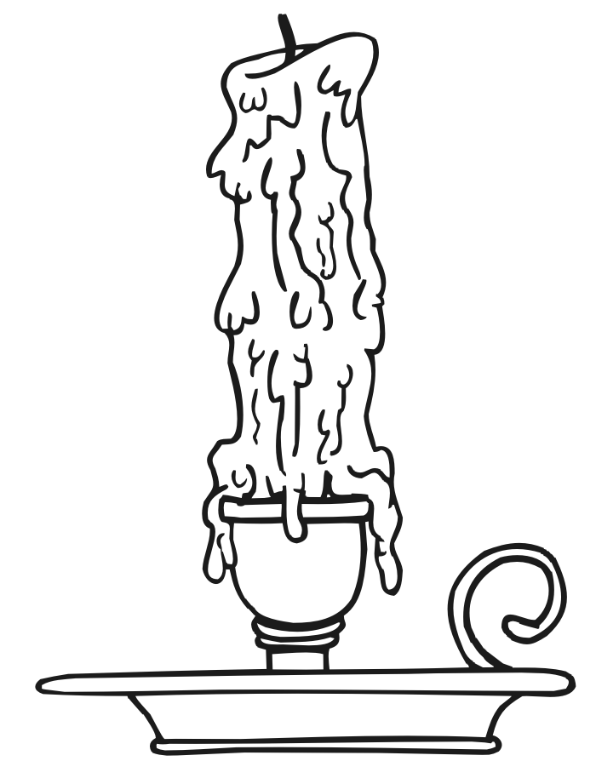

Matter

V | J | Z | G | G | T | A | C | V | D | S | K | E | U | T
G | A | M | G | N | Z | S | O | M | D | I | P | I | S | N
Y | N | P | W | U | I | T | N | Q | A | A | P | U | X | E
D | I | L | O | S | W | Z | D | I | H | T | B | A | V | M
R | V | I | B | R | A | T | E | S | Y | L | T | G | R | E
O | E | K | B | D | I | D | N | E | I | D | A | E | E | V
L | B | X | U | A | E | Z | S | M | R | S | Q | G | R | O
L | E | L | C | I | T | R | A | P | F | F | J | D | O | M
T | S | J | B | W | A | T | T | T | U | F | G | T | N | X
O | P | H | V | N | I | K | I | Q | I | N | S | L | F | T
Q | A | O | D | O | Z | D | O | D | I | O | M | I | D | N
T | W | O | N | Y | P | P | N | T | B | I | N | Q | E | W
I | M | S | T | A | T | E | L | E | P | O | E | U | X | A
H | W | X | V | J | J | E | K | M | Z | A | N | I | I | H
M | N | D | A | H | M | I | G | G | A | X | K | D | F | F

BOND | CONDENSATION | FIXED
FREEZING | GAS | LIQUID
MATTER | MELTING | MOVEMENT
PARTICLE | RANDOM | RAPID
ROLL | SHAPE | SOLID
STATE | SUBLIMATION | VAPORIZATION
VIBRATE

